# Section 19.5: The Final Journey – Phase 5: The Parinibbāna

As we saw in Section 19.4, the Blessed One completed the last leg of his final journey by entering the gateway of the beautiful Sāla grove of the Mallas at Kusinārā. Before we describe the profound events that unfolded there, it is helpful to clarify the terms *Nibbāna* and *Parinibbāna* for the benefit of readers.

## What is Nibbāna? What is Parinibbāna?

According to the teachings of the Buddha, Nibbāna is the complete liberation from the cycle of *saṃsāra*—the ongoing process of birth, aging, sickness, and death. It is the extinguishing of the causes that keep this cycle turning: namely, greed (*lobha*), hatred (*dosa*), and delusion (*moha*). Nibbāna is the state of complete freedom from suffering and defilements. This state is often described as Nibbāna as well as Parinibbāna.

While *Nibbāna* refers to this liberated state, *Parinibbāna* specifically refers to the final passing away of an arahant—when the five aggregates cease entirely at the time of death, and there is no further rebirth. In the case of the Buddha, this event is referred to with great reverence as *Mahāparinibbāna*—"the Great Final Passing Away"—emphasizing that he was not only a fully-liberated arahant but also the perfectly enlightened Tathāgata.

### The Buddha described this liberation in several suttas:

*“Therefore, bhikkhus, through the complete destruction, fading away, cessation, giving up, and relinquishing of craving, the Tathāgata has awakened to supreme full enlightenment…”*  
*(MN 1: Mūlapariyāya Sutta)*

*“Bhikkhus, this is the direct path for the purification of beings, for the surmounting of sorrow and lamentation, for the disappearance of pain and grief, for the attainment of the true way, for the realisation of Nibbāna—namely, the four foundations of mindfulness…”  
(MN 10: Satipaṭṭhāna Sutta)*

“*Bhikkhus, when ignorance is abandoned and true knowledge has arisen in a bhikkhu, then …he no longer clings to sensual pleasures, no longer clings to views, no longer clings to rules and observances, no longer clings to a doctrine of self. When he does not cling, he is not agitated. When he is not agitated, he personally attains Nibbāna. He understands: ‘Birth is destroyed, the holy life has been lived, what had to be done has been done, there is no more coming to any state of being.’” (MN 11: Cūḷasīhanāda Sutta)*

*“Then the bhikkhus of the group of five… seeking the unaging, unailing, deathless, sorrowless, and undefiled supreme security from bondage—Nibbāna—they attained it. The knowledge and vision arose in them: ‘Our deliverance is unshakeable; this is our last birth; there is no renewal of being.’” (MN 26: Ariyapariyesanā Sutta)*

### Renowned Buddhist scholars have further clarified the distinction:

**Bhikkhu Nyanatiloka writes:**  
*“Nibbāna (Skt. nirvāṇa, from nir + vā ‘to cease blowing, to become extinguished’)—freedom from desire—is the highest and ultimate goal of all Buddhist aspiration. It is the absolute extinction of the life-affirming will manifested as greed, hatred, and delusion. Parinibbāna (‘Full Nibbāna’) is a synonym for Nibbāna, and though often applied to the extinction of the five aggregates at death, it is not exclusively limited to that event.”* [1]

**Bhikkhu Bodhi notes:**  
*“While it is often said that Nibbāna is the experience of release in life and Parinibbāna is its full realization at death, this is a simplification. The prefix pari- transforms a verb from expressing a state to expressing the attainment of that state. Thus, nibbāna refers to the state of release, while parinibbāna denotes its full achievement—either during life or at the moment of physical dissolution.”*

In this way, the Buddha's *Mahāparinibbāna* was not simply the death of a person, but the final and complete extinguishing of all conditioned existence—*anupādisesa-nibbāna-dhātu*, the element of Nibbāna without remainder.[2]

With this understanding of *Nibbāna* and *Parinibbāna*, we are better prepared to approach the final moments of the Blessed One’s life with clarity and reverence. What took place in the Sāla grove of the Mallas was not merely the physical passing of a great teacher, but the culmination of an extraordinary life fully lived in Dhamma. As the Buddha lay on his right side between the twin Sāla trees, surrounded by disciples and devas, the serene and majestic scene became the setting for his final teaching and the Great Passing Away—*Mahāparinibbāna*.

## Kusinārā – The Sacred Ground of the Final Resting Place

At the time of the Blessed One, Kusinārā was the capital city of the Malla kingdom, one of the sixteen *Mahājanapadas*—the great realms that flourished in ancient India from the sixth to fourth centuries BCE (see Map 1 below). While not among the most prosperous or well-known cities of the time, this humble town held a deep and hidden significance in the arc of the Buddha’s vast journey.

Earlier in this work (Section 3), we noted that when the young Prince Siddhattha renounced the palace life of Kapilavatthu at the age of twenty-nine, he travelled eastward and reached the Anupiya Mango Grove near Kusinārā. It was there that he removed his princely attire, shaved his head, and entered the homeless life in search of the deathless. Now, as the fully awakened Buddha, he returned to this region—close to that very grove—as he prepared to breathe his last. **The arc had come full circle.** (see the picture below)

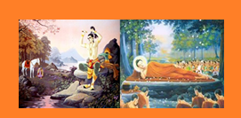

Though Kusinārā appeared modest and remote at the time, the Buddha’s selection of this place was not arbitrary. As he once revealed, the Bodhisatta had, in previous lives, laid down his body in this very spot seven times. [3]Now, as the Perfectly Enlightened One, he would lie here for the eighth and final time—with no more rebirth to come. What may have seemed an insignificant village to the eyes of the world was, in truth, a site sanctified by great resolve, deep past-life aspiration, and the fulfillment of a timeless vow.

Even so, Venerable Ānanda, overwhelmed with concern, voiced his sadness that such a “**small, wattle-and-daub town in the jungle**” should be the place of the Buddha’s passing. He reminded the Blessed One of the many great cities—Rājagaha, Sāvatthī, Kosambī, Vārāṇasī—where powerful and devoted followers could offer a grand farewell.

The Buddha, ever composed, gently corrected Ānanda. He reminded him that all things—cities, wealth, fame—rise and fall. He revealed that Kusinārā had once been Kusāvatī, a glorious capital ruled by King Mahāsudassana, a wheel-turning monarch. [4] In those days, it rivalled even the celestial city of Ālakamandā, the abode of the deva king Kuvera.[5]

Now it had faded—but this fading too was part of the Dhamma, the law of impermanence. To those who see with the eye of wisdom, no place is insignificant when touched by Dhamma.

Thus, the Buddha’s final resting place was chosen not by worldly considerations, but by a deep alignment with truth, past vows, and the profound teaching of *anicca*—impermanence. And so, in this humble grove of Sāla trees, the most sacred event in Buddhist history was about to unfold.

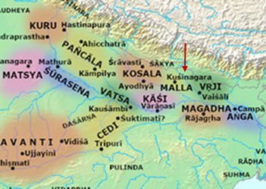

**Map 1: The Sixteen Mahājanapadas [6]**  
This map illustrates the major kingdoms of ancient India during the time of the Buddha. The Malla kingdom, with its capital at Kusinārā, is shown alongside other prominent kingdoms

such as Kosala, Magadha, and Vajjī.

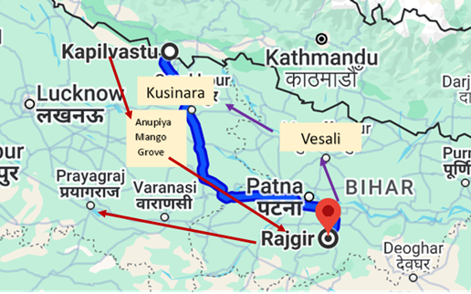

**Map 2: The Buddha’s Renunciation and Final Journey[7]**  
The route from Kapilavatthu to Anupiya Mango Grove marks the early phase of the Bodhisatta’s quest. Decades later, the path from Rājagaha to Kusinārā marks the final journey of the fully Enlightened One, completing the great circle of the Buddha’s earthly life*.*

**1 route**: Distance from Kapialavattu visa Anupiya Mango grove near Kusinara to Rājagaha 472 km, Rājagaha to Uruvela located in Varanasi 302 km 2 **route2** : Final Journey: Rājagaha to Kusinara via Vesali 472 km.

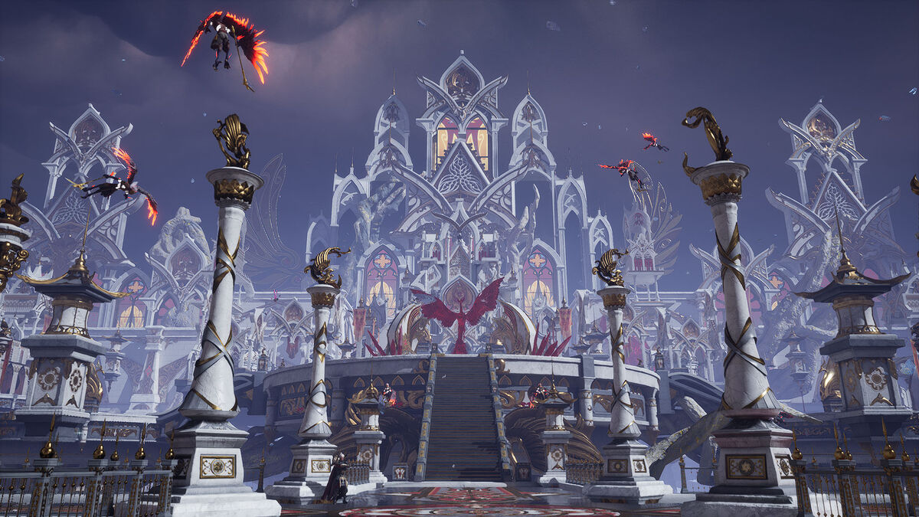

**Image: Ancient Kusinārā / Artistic impression of King Mahāsudassana’s Kusāvatī [8]**  
*The Buddha described Kusinārā as once being the magnificent royal city of Kusāvatī, ruled by King Mahāsudassana. This image helps us envision the grandeur of that ancient past, and the timeless message of impermanence he shared.*

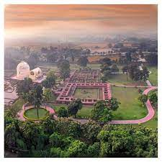

**Modern-day Kushinagr- an aerial view [9]**

## Events at the Sāla Grove Before the Mahāparinibbāna

The Blessed One had arrived in Kusinārā and was received with honour by the Mallas, who invited him to rest in the serene *Sāla* grove of *Upavattana*, just outside the city. There, between two majestic twin *Sāla* trees—suddenly blossoming out of season—the Buddha chose his final resting place. A couch was prepared for him with its head to the north, and the Blessed One lay down on his right side in the lion’s posture, composed and mindful.

The scene was both solemn and sublime. The twin trees shed their blossoms in homage, and celestial flowers rained down from the sky. Heavenly music and fragrances filled the air, as devas from distant realms gathered silently to pay their respects. Around the Enlightened One, disciples—both human and celestial—sat with reverent stillness, aware that the final phase of the Tathāgata’s great journey was about to unfold.

## How to Truly Honour the Tathāgata

Even in these final moments, the ever-compassionate Teacher offered his disciples a profound teaching—not on rituals or grand gestures, but on the true way to honour the Buddha. He said to Venerable Ānanda:

“Ānanda, these *sāla*-trees have burst forth into an abundance of untimely blossoms … divine music and song sound from the sky in homage to the Tathāgata. Never before has the Tathāgata been so honoured, revered, esteemed, worshipped, and adored.

**And yet, Ānanda, whatever monk, nun, male or female lay-follower dwells practising the Dhamma properly and perfectly fulfils the Dhamma-way—he or she honours the Tathāgata, reveres and esteems him, and pays him the supreme homage.**

Therefore, Ānanda, *‘We will dwell practising the Dhamma properly and perfectly fulfil the Dhamma-way’*—this must be your watchword.”[10]

### The Devas Paying Homage

As the Buddha rested peacefully between the twin *sāla* trees, many of his disciples sat nearby in quiet sorrow. Among them was Venerable Upavāṇa, who stood close by, fanning the Blessed One. Suddenly, the Buddha gently asked Upavāṇa to step aside.

Venerable Ānanda, surprised by this, respectfully asked the reason for the request. Upavāṇa had been attending to the Buddha with devotion—why should he move?

The Buddha, always kind and full of wisdom, gave this gentle reply:

“Ānanda, the devas from ten world-spheres have gathered to see the Tathāgata. For a distance of twelve *yojanas* around this *sāla*-grove, there is not a space you could touch with the tip of a hair that is not filled with mighty devas.

And they are lamenting: ‘We have come a long way to see the Tathāgata. Rare is the arising of a Tathāgata, a fully Enlightened One, in this world—and tonight, in the last watch, the Tathāgata will attain final Nibbāna. Yet this great monk is standing before the Lord, blocking our last glimpse of him!’”

Venerable Ānanda, though only a stream-enterer at the time, understood the gentle wisdom in the Buddha’s words.

### The Different Reactions of Devas

Then Ānanda asked, “But, Lord, what kind of devas can the Blessed One perceive?”

The Buddha replied:

“Ānanda, there are sky-devas whose minds are still bound to the earth. They are weeping, tearing their hair, raising their arms, throwing themselves down, twisting and turning, crying: ‘All too soon the Blessed One is passing away! All too soon the Well-Farer is departing! All too soon the Eye of the World is vanishing!’

There are also earth-devas with similarly bound minds, doing the same.

But those devas who are free from attachment—those from higher realms, including non-returners—bear the moment patiently, understanding: *‘All compounded things are impermanent. What is the use of sorrow?’*”[11]

### Four Places to Remember the Blessed One

Ever kind and always considering the welfare of others, Venerable Ānanda grew concerned for his brothers and sisters of the Saṅgha, scattered across distant lands, many living in seclusion and unaware that their beloved Master was soon to pass away. He also thought with deep compassion of the devoted householders—faithful laymen and laywomen—who had nurtured the growth of the Dispensation and who, too, were far away from Kusinārā, not knowing that the Blessed One’s final passing was only a few hours away.

Moved by this tender concern, Venerable Ānanda approached the Buddha and said:

*"Lord, in former times, monks who had spent the Rains in various places would come to see the Tathāgata, and we would welcome them, so that such well-trained monks might behold the Blessed One and pay their respects. But after the Lord’s passing, we shall no longer have the chance to do this."[12]*

The ever-compassionate Buddha, understanding Ānanda’s heartfelt sorrow, gently consoled him and gave this timeless teaching:

"Ānanda, there are four places the sight of which should arouse emotion in the faithful. Which are they?

* ‘Here the Tathāgata was born’—this is the first.
* ‘Here the Tathāgata attained Supreme Enlightenment’—this is the second.
* ‘Here the Tathāgata set in motion the Wheel of Dhamma’—this is the third.
* ‘Here the Tathāgata attained the Nibbāna-element without remainder’—this is the fourth.

And, Ānanda, faithful monks, nuns, male lay-followers, and female lay-followers will visit these places with hearts full of devotion. And any who die while making the pilgrimage to these sacred shrines with a devout heart will, at the breaking-up of the body, after death, be reborn in a heavenly world."

The Four Sacred Places of Pilgrimage  
*"The Blessed One, out of compassion, pointed out these four sacred places, saying that the faithful should visit them and recollect the Tathāgata with a devoted heart."[13]*

* Lumbinī (Birthplace)
* Bodhgayā (Enlightenment)
* Sarnath (First Sermon)
* Kusinārā (Mahāparinibbāna)

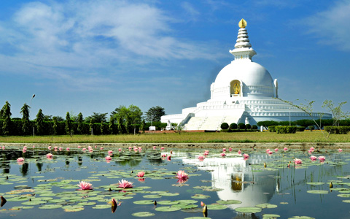

**1. Lumbinī – The Blessed Birth[14]**  
*"Here the Tathāgata was born."*

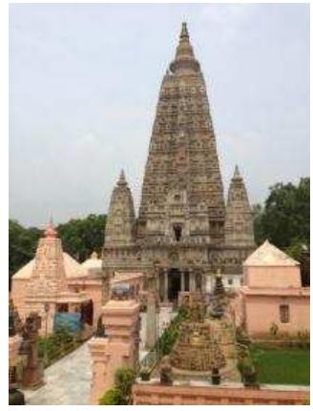

**2. Bodhgayā – The Supreme Enlightenment**-[15]

*"Here the Tathāgata attained Supreme Enlightenment."*

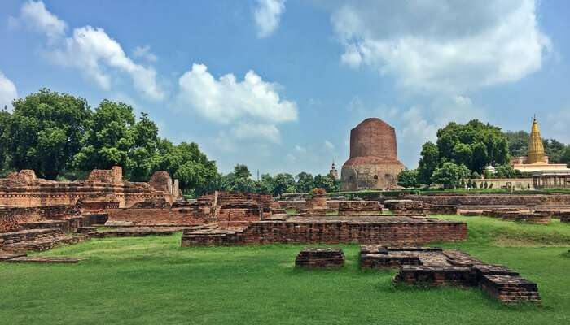

**3. Sarnath – The Turning of the Wheel of Dhamma[16]**  
*"Here the Tathāgata set in motion the Wheel of Dhamma."*

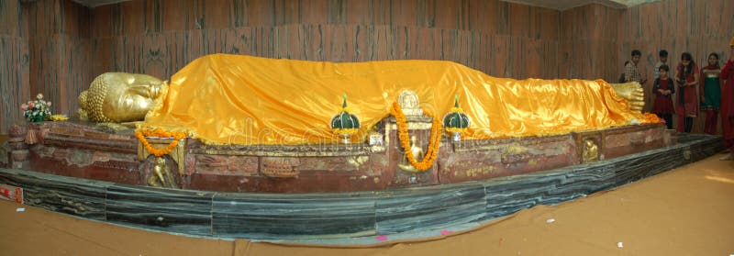**4. Kusinārā – The Great Passing Beyond [17]**  
*"Here the Tathāgata attained the Nibbāna-element without remainder."*

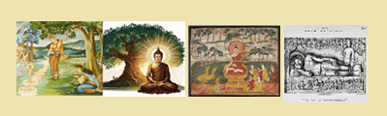

**The Fur Holy Places**

These places are not merely markers of history, but living reminders of the Blessed One’s boundless compassion and tireless effort for the welfare of all beings. To walk where he **walked, to reflect where he taught, and to bow where he attained release, is to let the Dhamma touch the heart in a most personal way.**

### How to Honour the Tathāgatha’s Remains

As the Blessed One lay resting peacefully between the twin Sāla trees, Venerable Ānanda, sensing that the final hour was drawing near, began to ponder with a heavy heart:  
*"How should we honour the Tathāgata's remains? What should be done with the body of the Blessed One after his Parinibbāna?"*

Approaching the Buddha with deep reverence, Venerable Ānanda asked:  
*"Lord, what shall we do with the Tathāgata’s remains?"[18]*

The Blessed One, ever concerned for the welfare of his disciples even in his final moments, answered with gentle wisdom. He reminded Venerable Ānanda of the true duty of an ascetic — **the highest task they should devote themselves to**:

"Ānanda, do not busy yourselves with funeral arrangements for the Tathāgata. Rather, you should strive with diligence for your own highest good — for the attainment of Arahantship. Dwell with your minds devoted, energetic, and steadfast toward liberation. As for the funeral rites, there are wise and devoted Khattiyas, Brahmins, and householders who hold the Tathāgata dear; they will see to those duties."

Thus, even at the threshold of his Parinibbāna, the Blessed One’s mind remained perfectly clear, focused on guiding his disciples to liberation. His words were a gentle but urgent reminder that the true honouring of the Buddha was not in ceremonies or rituals, but in earnest practice — in striving to realize Nibbāna.

### Building Stupas to honour the Buddha

Yet, for the benefit of the wider community of followers — the devoted laypeople who would come after — the Buddha compassionately gave further instructions. He explained that after the Parinibbāna, a stupa should be erected at a crossroads over the remains of the Tathāgata. He said:

***"Whoever lays garlands, or applies sweet perfumes and colours there, with a devout heart, will gain benefit and happiness for a long time."***

This teaching shows the profound understanding of human nature held by the Buddha. Recognizing that lay followers, though not yet ready for deep renunciation, could develop faith and spiritual joy through acts of homage, he provided a practice suited for them. Through these offerings at stupas — acts done with a pure and devout heart — they could cultivate merit, strengthen their connection to the Buddha, and deepen their trust in the Dhamma and the Sangha.

Even today, in Buddhist cultures across the world, this tradition lives on. Devotees offer flowers, incense, and lights at temples, monasteries, Buddha statues, and ancient stupas. Some modern minds, unfamiliar with the roots of these practices, may dismiss them as mere rituals. But when we reflect on the Blessed One’s final teachings, we realize that these acts, when performed with devotion and mindfulness, are powerful expressions of gratitude and reverence — and pathways toward spiritual growth.

Thus, the practice of homage at stupas was not born of superstition but of profound compassion. It is a legacy of the Buddha himself, foreseeing that in future generations, these sacred acts would sustain the faith of countless beings and keep the light of the Dhamma shining brightly in the world.

**Note:**

The tradition and scriptures conformed that eight stupas contain the remains “relics” of the Blessed One and two others were built: one using the urn which measured the remains and the second one using the embers of the funeral pyre. We will give detail of this account in our next section.

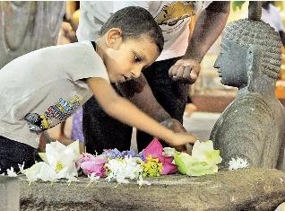

**Offering flowers at the feet of the Buddha[19]**

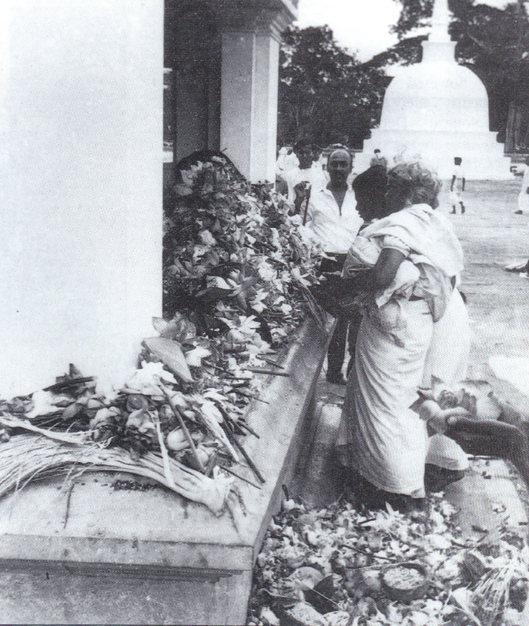

**Devotees Offerings flowers at a Stupa[20]**

## In the Light of Parting: The Teacher’s Heartfelt Gratitude to Ānanda

In the twilight of the Blessed One’s life, as the final moments drew near, a deep sorrow stirred in the heart of the Venerable Ānanda. Quietly withdrawing to his lodging, he leaned heavily against the doorpost, overcome with grief. Tears welled in his eyes as he as he whispered in anguish:[21]

*"Alas! Still am I a learner with much left undone…  
And now, the Compassionate Teacher,*

*the Light of the World, is slipping away."*

Sensing the quiet absence of his faithful companion, the Blessed One asked the monks,  
"Where is Ānanda?"  
And when they told him, he said gently,

"Go, monk, and summon Ānanda."

The monk went swiftly, delivering the message:

"Friend Ānanda, the Teacher calls for you."

**"**Very good, friend," Ānanda replied with devotion, and at once he went to the Blessed One. Having bowed low in reverence, he sat quietly to one side, his heart trembling.

The Blessed One gazed upon him with deep kindness and said:

"Enough, Ānanda. Weep not.  
Have I not long taught you that **all that is beloved and delightful must, by nature, change and pass away?**

How could it be, Ānanda, that **what is born, arisen, compounded, should not also fade**?

For countless years you have been by the Tathāgata’s side, offering loving-kindness in body, speech, and mind — always beneficent, always blessed, always whole-hearted and unstinting. You have gathered abundant merit, Ānanda. Strive earnestly now, and in a little while, freedom from the taints shall be yours."

Then, turning to the gathering of monks, the Blessed One proclaimed:

"Monks, all the Arahant, Fully Enlightened Buddhas of the past have been served by such a chief attendant as Ānanda, and so too shall it be for the Buddhas yet to come.

Ānanda is wise and discerning. He knows the fitting time for monks to approach the Tathāgata, the fitting time for nuns, laymen, laywomen, kings, royal ministers, seekers, and followers alike.

And there are four wondrous and rare qualities he possesses:

* When a company of monks approaches Ānanda, their hearts lift at the sight of him.
* They rejoice in the hearing of the Dhamma from his lips.
* And when he falls silent, they feel a sweet longing, a gentle sadness, as if a precious music has ended.
* And so it is, too, with nuns, laymen, and laywomen.

These same qualities, monks, shine also in a righteous Wheel-turning Monarch.  
And so it is with Ānanda."

Thus, even as the sands of his life ran low, the Blessed One poured forth his deep gratitude and love for the faithful heart that had walked beside him — a shining testament to the beauty of loving service, and the timeless, tender bond between Teacher and disciple.

#### A Short Dhamma Reflection of the Teachings

In a world where all things are subject to change, the beauty of gratitude endures beyond birth and death. The Blessed One’s words to Ānanda remind us: Loving service offered with purity of heart is never lost.  
Even as forms pass away, the goodness born of kindness, devotion, and faith continues to shine — like the morning star that heralds a new dawn.

“In the garden of the Dhamma, there bloomed a heart so tender and true —  
A heart that wept for the Teacher, yet shone with the fragrance of timeless devotion.  
Thus the name Ānanda — ‘bliss’ — shall forever whisper through the ages,  
A soft, golden echo of love that does not die.”

#### Venerable Ānanda’s Sorrow – Like a Lotus at the SunSet**🌿**

In that sacred hour when the sun of the world was setting,

In the hush of the dying day, as the Blessed One’s light began to wane,

Ānanda stood alone by the doorway, his heart heavy beyond words.

as if the weight of a thousand lifetimes pressed upon his gentle heart.

His sorrow was like a pure lotus — that, sensing the setting sun,

slowly closes its petals —  
not in despair, but in a silent homage —

to the fading of the day, it loved.

Tears welled like rain from a cloud heavy with longing —  
for how could one bear to part from the One —

the One who was his refuge, one who was the source of all peace?

his guiding star, his very breath of hope?

Yet even in that aching sorrow,

a fragrance of deep gratitude arose —  
for to serve the Blessed One, to walk beside him —

even for a little while,  
was to have lived a life touched by the eternal.

Beneath the ancient trees,

as the winds whispered of impermanence,  
Ānanda’s sorrow became the sorrow of all —

who love and must one day say farewell.  
Yet within that grief, there stirred also the purest gratitude —  
for to have walked even one step with the Blessed One —

was a blessing beyond measure! **🌸 [22]**

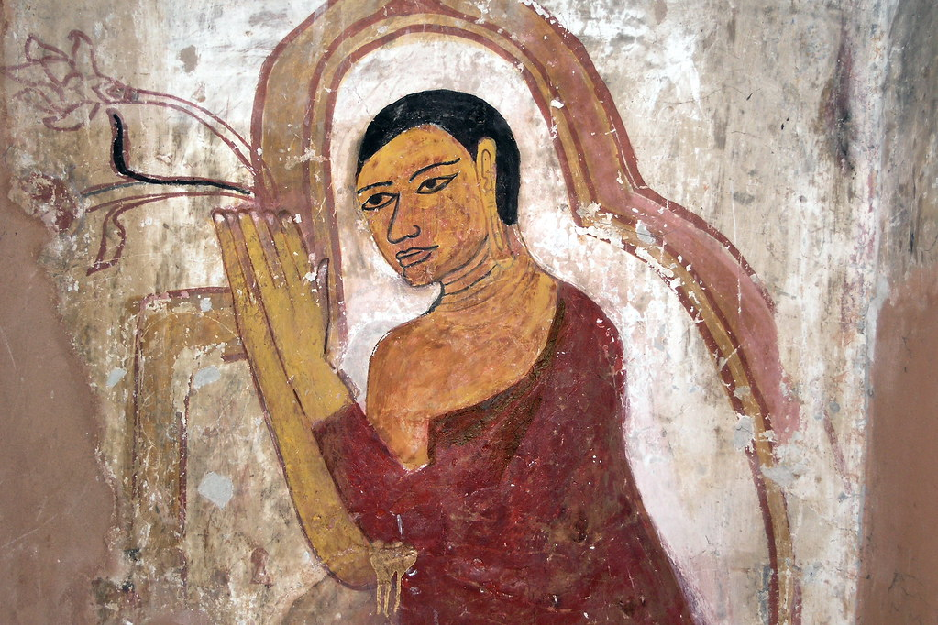**Venerable Ãnanda’s last homage to the Blessed One [23]**

#### Dedication to Venerable Ānanda:

Heart of devotion, mirror of compassion,  
whose tender sorrow at the Teacher’s passing  
shines across the ages like a lotus touched by the setting sun.

Homage to you, faithful friend of the Blessed One!

Gentle guardian of the Dhamma,  
whose tears were the rain that nourished the roots of wisdom.

Through your faithful love, Dear Venerable,  
the Blessed One’s words became the world’s undying light.

**Our Wish**

May we, like Venerable Ānanda, serve the Dhamma with a heart of loving-kindness, humility, and tireless devotion, remembering always that in every moment of gratitude and faith, we draw closer to freedom from all suffering!

May the faithful love of Venerable Ānanda inspire all beings to walk the Noble Path with devotion and steadfastness, until they too reach the far shore of Nibbāna!

May these humble offerings of devotion awaken a deeper faith in the hearts of all who read,  
and may the tears of Ānanda remind us that love, service, and the Dhamma endure beyond time.

## The Announcement of the Blessed One’s Final Nibbāna

Even in his final hour, the Blessed One remained ever mindful, urging Venerable Ānanda to fulfill a final duty of compassion: to inform the Mallas of Kusinārā of his impending passing.

"Ānanda," he said, "go to the Mallas and announce: *‘Tonight, in the last watch, the Tathāgata will attain final Nibbāna. Come, Vasetthas, lest later you regret, saying: ‘The Tathāgata passed away among us, and we did not have the chance to see him for the last time.’*"[24]

Venerable Ānanda, faithful and devoted, set out immediately with a companion. The Mallas, gathered in their council hall, were struck with deep grief upon hearing the news. With heavy hearts, along with their families and attendants, they rushed to the sala grove where the Blessed One lay.

Although Venerable Ānanda’s heart ached with sorrow, his kindness and wisdom prevailed. Considering the Blessed One’s remaining time, he arranged for the Mallas to pay their final respects family by family. Thus, all were able to honour the Buddha in the first watch of the night, offering their last homage at his sacred feet.

Reflection:  
In these final moments, the Blessed One showed us once again the beauty of mindfulness, compassion, and care for others. Even facing death, he thought first of those who loved him, ensuring they would not be left with regret. May we too, in our lives, practice such mindfulness and kindness — never missing the chance to honour what is noble, and to give devotion while we still have time.

## Subhadda’s Good Fortune — The Last Personal Disciple of the Blessed One

As the Blessed One lay in his final hours, a wanderer named Subhadda, hearing that the Great Sage would soon attain final Nibbāna, felt a stirring in his heart.

*"A Tathāgata, a fully awakened Buddha, rarely arises in this world,"* he thought. *"And tonight the ascetic Gotama will pass beyond. A doubt troubles my mind — surely he can dispel it."*

Subhadda hurried to the sala grove and asked Venerable Ānanda for permission to see the Blessed One. Concerned for the Lord’s rest, Ānanda at first gently refused him. Yet the Blessed One, hearing their conversation, said:

*"Do not hinder Subhadda, Ānanda. Let him approach. His questions are asked not to trouble me, but in search of the Dhamma."*

Coming before the Buddha, Subhadda asked about the true path among the many teachers of the day. With boundless compassion, the Blessed One answered:

***"Wherever the Noble Eightfold Path is not found, true ascetics are not found. But wherever this Path is found, there are true saints, of the first, second, third, and fourth degree. And in this Dhamma and Discipline, Subhadda, the Noble Eightfold Path is fully present. If the monks live this path perfectly, the world will never be without Arahants."***

Hearing this clear teaching, Subhadda was filled with faith and joy. He declared himself a follower of the Buddha, the Dhamma, and the Sangha, and humbly sought ordination. The Blessed One, seeing his sincerity, granted it immediately.

Through diligent practice, Subhadda swiftly attained the goal for which the holy life is lived — Arahantship. He realized the deathless, completed the journey, and was freed. Thus, Subhadda became the Blessed One’s final personal disciple.

Reflection:  
In his last moments, the Blessed One still opened the door of liberation for those who sincerely sought the truth. Subhadda’s story reminds us:

**it is never too late to awaken. A single meeting with the Dhamma, taken to heart and practiced with sincerity, can bring about the highest blessing — the end of suffering**.

May we, too, never delay in seeking what is most precious!

## The Final Teachings of the Blessed One

Even as his last breath approached, the Compassionate Teacher — ever mindful, ever merciful — did not leave his disciples without shelter. Out of boundless love, he gave them a refuge that would never perish:

***"Hereafter, the Dhamma and the discipline shall be your teacher."***

Turning to Venerable Ānanda, the Blessed One said:  
*"It may be, Ānanda, that you will think: ‘The Teacher’s instruction has ceased; now we have no teacher.’ But it should not be seen in this way. That which I have taught and explained as Dhamma and discipline — that will be your guide, your refuge, your protector."*

Then, addressing the assembly of monks for the final time, the Lord spoke:  
*"If any among you has any doubt or uncertainty about the Buddha, the Dhamma, the Sangha, or the path and the practice, ask now, do not harbor regret later, thinking: ‘The Teacher was before us and we did not ask.’"*

Three times he invited questions. Three times the monks remained silent — not from hesitation, but from deep clarity and trust. Venerable Ānanda marvelled at their silence and said:  
*"It is wonderful, Lord, it is marvellous! I clearly perceive that in this assembly there is not a single monk who harbors doubt or uncertainty."*

The Blessed One confirmed:  
*"Ānanda, you speak from faith. But the Tathāgata knows: among these five hundred monks, the least is a Stream-Winner, one assured of final liberation, incapable of falling away."*

(It is understood that these were the devoted disciples who had followed the Blessed One throughout his final journey — from Sāvatthī to Rājagaha, and from there all the way to Kusinārā.)

As the twilight deepened and silence enveloped the Sāla grove, the Blessed One addressed the assembly with gentle dignity. He offered final words of Dhamma—simple, direct, and luminous with wisdom. And finally, the Blessed One, the greatest of teachers, declared:

**"Now, monks, I declare to you:  
All conditioned things are subject to decay — Strive on untiringly."**

*(Vayadhammā saṅkhārā – appamādena sampādetha)*

These were the last words of the Tathāgata, a timeless reminder of the impermanence of all things and the necessity of unrelenting effort on the path of liberation.

#### The Final call -echoes through the ages

In his final moments, the Buddha’s compassion shone with undiminished brilliance. He did not point to himself, but to the timeless Dhamma as the true refuge. His departure was not a loss but a reminder that what is essential — the path to freedom — is untouched by death.

The silence of the assembly speaks volumes: they were not left orphaned, for the true Teacher now lived within their hearts, through the Dhamma they had realized.

The Blessed One’s last words are a call that echoes through the ages:  
Nothing here will last — so live with urgency, with diligence, with unwavering resolve.

Each breath we have is precious. Each moment can be turned toward the Deathless. Let us not delay. Let us honour the Blessed One’s gift with hearts that strive!

At the setting of the final sun,   
The Teacher spoke with boundless grace:  
*"Decay is the nature of all things —  
Strive on, with steady pace."*

He left no golden crown or throne,  
But the lamp of Truth to light the way —  
A flame that death could not dethrone,  
A path to dawn beyond decay!

**Silent Contemplation:**

Close your eyes for a moment, Let the noise of the world fall away.

Imagine yourself among those gathered by the sala trees,  
feeling the cool night air, the soft murmur of leaves,  
the radiance of the Blessed One’s final presence.

Feel the weight of his words:  
*"All conditioned things are subject to decay — strive on untiringly."*

Let them settle deep into your heart.  
What, in your own life, is truly lasting?  
What remains when all else falls away?

May we too, like those noble disciples,  
hold fast to the Dhamma, walk with urgency and with faith,  
and strive to cross beyond sorrow.

Feel the weight of those words in your heart.  
Feel the preciousness of this fleeting life.  
Resolve now — with deep gratitude —  
to walk the path he opened,  
to carry the torch of the Dhamma onward.

Bow in silence.  
And let the journey continue — in you!

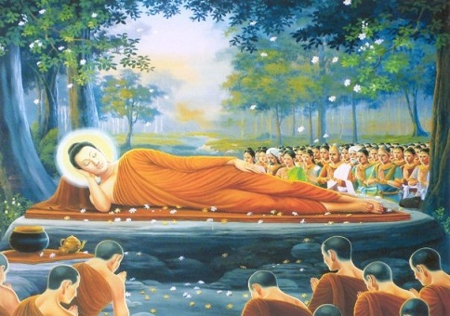

**And from the radiant stillness of the fourth jhāna, the Blessed One finally, peacefully, utterly — passed into Parinibbāna.[25]**

## The Blessed One’s Final Passing

Shortly after, the Blessed One entered into the meditative absorptions (*jhānas*) in sequence, gradually deepening his stillness. He entered the first jhāna, then the second, third, and fourth; then transcended into the formless attainments—space, consciousness, nothingness, and neither-perception-nor-non-perception. Then, reversing the order, he returned through each absorption until he reached the fourth jhāna once again.

And from there, utterly serene and composed, the Blessed One passed away—attaining *Mahāparinibbāna*—the complete liberation from all conditioned existence. There was no disturbance, no struggle, no sound—only stillness, like a flame going out when the fuel is gone.

The earth trembled. The skies wept flowers. Many among the gathered wept, while others, deeply composed, reflected on the impermanence of all things. Even the devas, who had come from vast realms to witness this moment, stood in silent reverence.

Thus, the one who had crossed beyond all suffering, the one who had shown the way to the Deathless, had now entered the Deathless himself.

In the sacred silence of the sala grove,  
the Blessed One, ever serene, entered the first jhāna,  
then the second, the third, and the fourth,  
his mind ascending the stillness like a swan rising into the sky.

Beyond form and feeling, he entered  
the Sphere of Infinite Space,  
then Infinite Consciousness,  
then into Nothingness,  
then Neither-Perception-Nor-Non-Perception.

Finally, he attained the sublime stillness —  
the Cessation of Feeling and Perception.

Venerable Ānanda, unable to perceive this depth, whispered:  
*"The Lord has passed away."*  
But Venerable Anuruddha, his vision vast and clear, replied:  
*"No, friend Ānanda — the Lord abides in deep cessation."[26]*

Then — as gently as the setting of the sun —  
the Blessed One returned step by step  
through the boundless spheres of meditation,  
descending through the fourth, third, second, and first jhāna.

Once more ascending to the second, the third, and the fourth jhāna —  
and from the radiant stillness of the fourth jhāna,  
the Blessed One finally, peacefully, utterly —  
**passed into Parinibbāna !**

The earth itself could not bear the weight of this moment.  
A great earthquake shook the worlds, thunder rolled across the skies, and those with divine vision uttered verses of awe and sorrow:

**Brahmā Sahampati proclaimed:**  
*"All beings in the world, all formations must break apart.  
Even the Teacher, peerless among humans, has passed away."*

**Sakka, ruler of the devas, declared:***"Impermanent are all conditioned things,  
their arising and falling is their nature.  
Having arisen, they cease;  
their calm cessation is true bliss."*

**The Venerable Anuruddha, the seer of celestial eyes, spoke:***"No more breathing in or out —  
with steadfast heart the Sage endures.  
Free from all attachments,  
by Nibbāna the Illumined’s mind is freed."*

**And Venerable Ānanda, beloved attendant cried:** *"Terrible was the trembling of the earth;  
men's hair stood on end,  
when the all-accomplished Buddha passed away."*

In silence, the world mourned — but in the hearts of the faithful, the light of the Dhamma blazed ever brighter, an eternal refuge beyond all sorrow.

**Silent Reflection:**

At the Blessed One’s final breath, the earth quaked,  
but his Great Heart was utterly still.  
He showed us, not just by words but by his final breath,  
the path to the Deathless.

May we remember:  
the greatest gift is the Dhamma.  
The greatest refuge is the Dhamma.  
And the greatest honour we can offer him  
is to walk the Path he revealed,  
with courage, with compassion,  
with an undying resolve.

Let us bow our heads, not in sorrow,  
but in deep gratitude,  
vowing to carry his light  
into this world still longing for peace.

**Homage to the Buddha, Perfectly Enlighten One !**

The winds grew still, the earth bowed low,  
As into peace the Awakened did go.  
No grasping, no sorrow, no last farewell —  
Just boundless silence where wisdom dwells.

O Light of the Worlds, though you passed from sight,  
Your Dhamma still shines, a deathless light.  
In footsteps gentle, on paths made clear,  
We follow, with trust, with love, with tears.

Namo Tassa Bhagavato, we vow anew:  
To live by your Way—  
to awaken, as you!

## Venerable Anuruddha’s Great Compassion

After the Blessed One’s Mahāparinibbāna, the sacred night grew silent. In the stillness, Venerable Anuruddha and Venerable Ānanda, two devoted disciples, sat together, their hearts tender with the immeasurable loss. Out of deep compassion, Venerable Anuruddha, wise and serene, remained by Venerable Ānanda’s side, speaking gently of the Dhamma.

He understood the depth of Venerable Ānanda’s sorrow — for though Ānanda had attained the first glimpse of liberation, he had not yet crossed beyond all suffering. Having served the Blessed One with boundless devotion, his heart was heavy with grief. Tenderly, Venerable Anuruddha comforted him, soothing his pain by recalling the Blessed One’s final teaching:

***"The Dhamma and Discipline I have taught will now be your Teacher, your refuge, and your guide."***

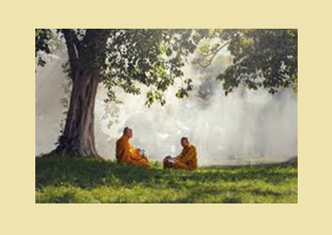

**Sitting under the Great Sala Tree Venerable Anuruddha, speaking gently of the Dhamma to Venerable Ānanda[27]**

Thus, through kindness and wisdom, Anuruddha helped his spiritual brother find strength again in the timeless refuge of the Dhamma. With this profound moment of compassion, we bring to a close the sacred account of the Blessed One’s final passing.

**Beneath the silent sala trees**

At the Silent Ending

Beneath the silent sala trees,  
the moon held still her breath;  
the Awakened One, serene and free,  
had gently crossed beyond all death.

In sorrow’s shade, two hearts remained,  
bound by love and faith so deep;  
one spoke with wisdom, soft and kind,  
to guide the other through his grief.

***"The Dhamma now shall be your light,  
your island in the darkened sea;  
the Teacher lives in timeless truth,  
within the heart of purity."***

So, through the night they sat and spoke,  
till grief gave way to peace again;  
beneath the stars, the Blessed Path  
rose brighter than the morning rain.

Now let us bow our heads and hearts,  
to honour He who led the way;  
and turn to Dhamma as our guide,  
our shelter, refuge, night and day.

The next section, 19-6, will honour the Great Funeral of the Buddha and the distribution of his sacred relics among his devoted followers.

### End Notes: Section19:5

1. Buddhist Dictionary by Bhikkhu Nyanatiloka
2. SN: Introduction, p, 37.
3. SN:17
4. DN:16: This story also elaborated in DN: 17 too.
5. Ibid.
6. Source: https://en.wikipedia.org/wiki/Mahajanapadas
7. Google map.
8. Source: https://softstar.fandom.com/wiki/Deva_Kingdom
9. Source: https://www.facebook.com/photo.php?fbid=4541080992573947&id=144113158937441&set=a.2548268571855209&locale=tl_PH
10. DN:16
11. Ibid.
12. DN:16
13. Ibid.
14. https://www.tibettravel.org/india-tibet-nepal-bhutan-tour/spiritual-odyssey-from-india-to-nepal-tibet-and-bhutan.html
15. https://www.academia.edu/12075727/An_account_of_the_rediscovery_of_Bodh_Gaya
16. https://traveltriangle.com/blog/things-to-do-in-sarnath/
17. https://www.dreamstime.com/kushinagar-india-december-buddha-gold-statue-mahaparinirvana-temple-kusinara-uttar-pradesh-reclining-parinivarna-ind-image120566266
18. DN:16
19. Source: https://www.pressreader.com/sri-lanka/daily-mirror-sri-lanka/20170609/282716226970975
20. Source: https://exploresrilanka.lk/an-offering-of-flowers/
21. DN:16
22. Poem composed by a dear friend who love and respect Venerable Ãnanda.
23. Source: [https://www.flickr.com/photos/asienman/14378017337*](https://www.flickr.com/photos/asienman/14378017337*) Myanmar - Bagan - Ananda Temple - Mural 
24. DN:16
25. Source: https://dharmasar.wordpress.com/2015/02/21/what-did-the-buddha-really-teach/
26. Ibid.
27. https://www.istockphoto.com/photos/two-monks